Challenge 2 _ Millegan

2018

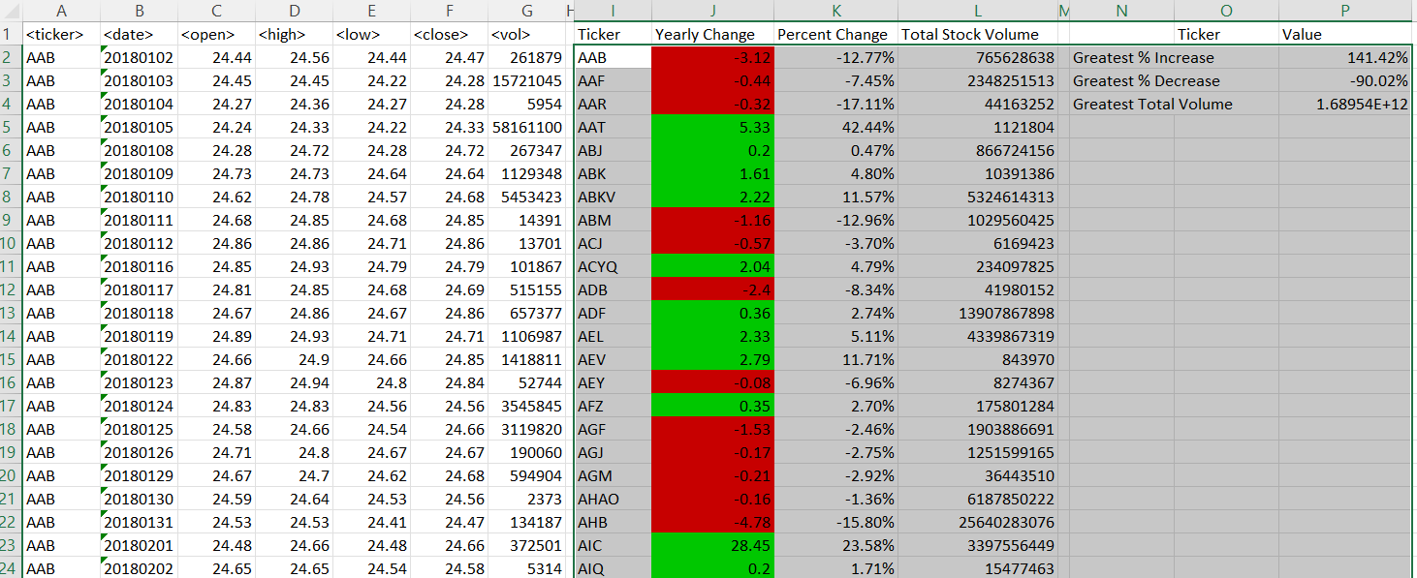

2019

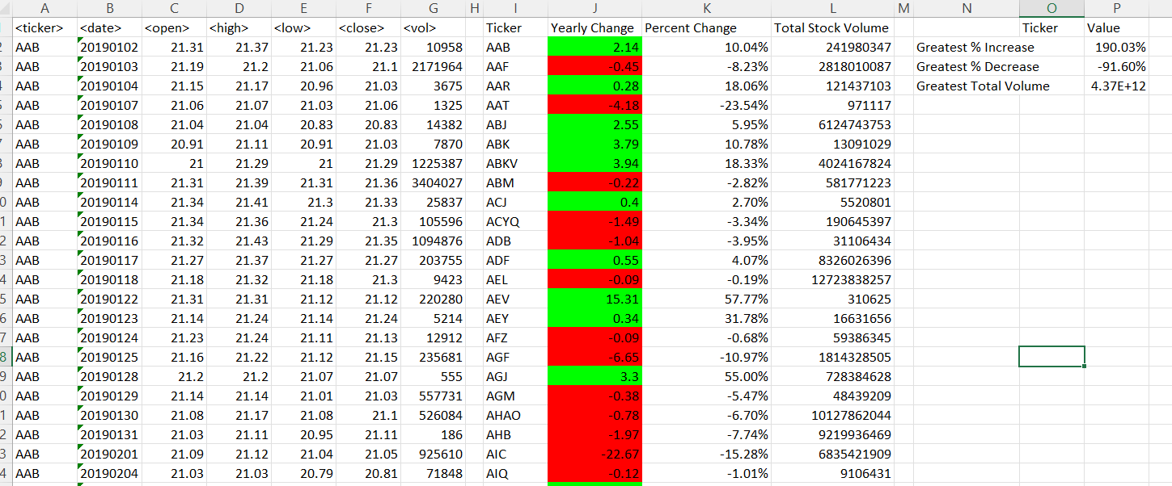

2020 See next page

